`INFORMATION MANAGEMENT

Exercise 1

1. Write the complete SQL statement for creating a new database called address book

CREATE DATABASE addressbook;

2. Which statement is used to list the information about a table? How do you use this statement?

CREATE TABLE employee_data (

emp_id int unsigned not null auto_increment primary key,

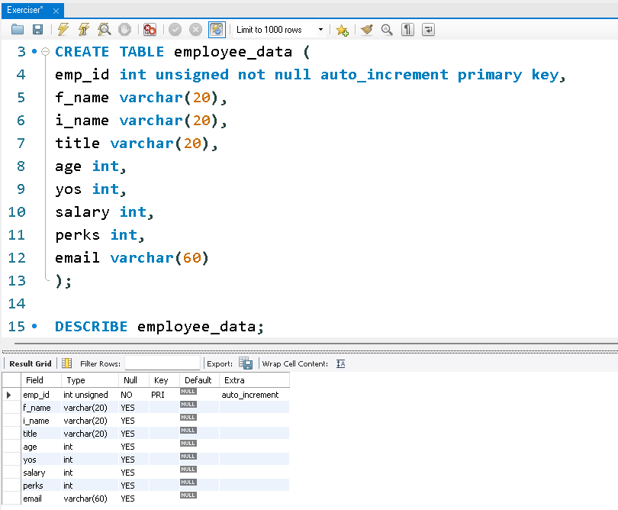f_name varchar(20),

l_name varchar(20),

title varchar(20),

age int,

yos int,

salary int,

perks int,

email varchar(60)

);

DESCRIBE employee_data;

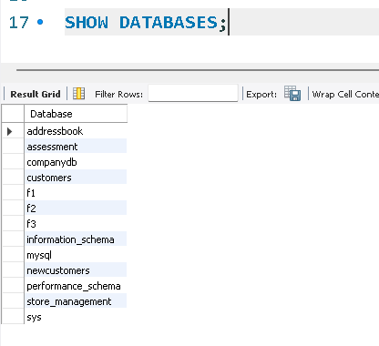3. How would you list all the databases available on the system?

SHOW DATABASES;

4. Write the statement for inserting the following data in employee_data table

INSERT INTO employee_data

(f_name, l_name, title, age, yos, salary, perks, email)

VALUES

('Rudolf', 'Reindeer', 'Business Analyst', 34, 2, 95000, 17000, 'rudolf@bugnet.com');

5. Give two forms of the SELECT statement that will list all the data in employee_data table

SELECT * FROM employee_data;

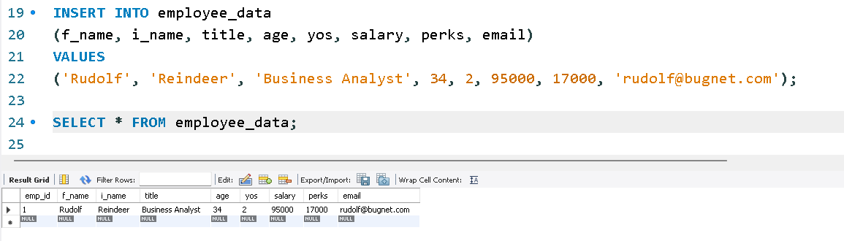

6. What will select f_name, email from employee_data; display?

SELECT f_name, email FROM employee_data;

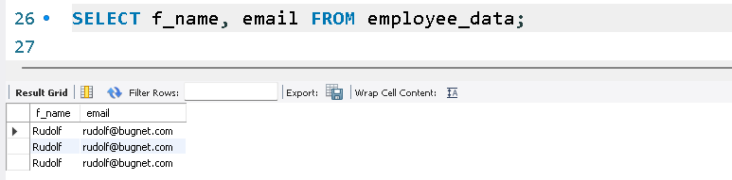

7. Write the statement for listing data from salary, perks and yos columns of employee_data table.

SELECT salary, perks, yos FROM employee_data;

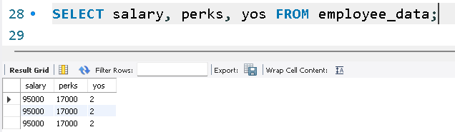

8. How can you find the number of rows in a table using the SELECT statement?

SELECT COUNT(*) FROM employee_data;

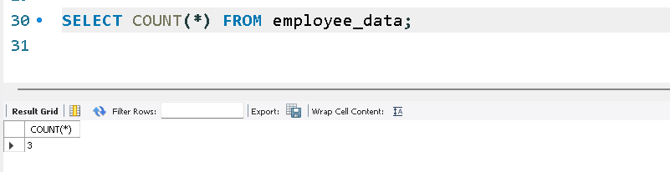

9. What will select salary, l_name from employee_data; display?

SELECT salary, i_name FROM employee_data; 